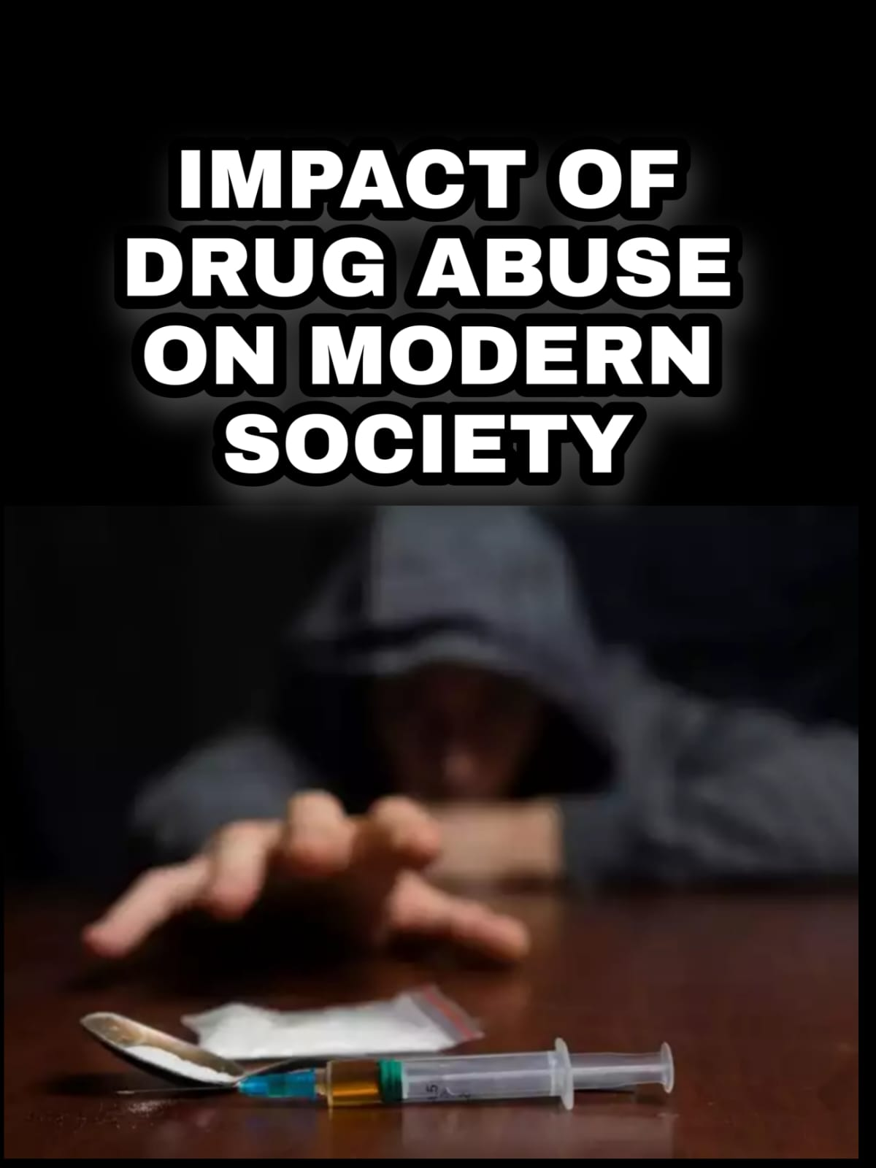



**“IMPACT OF DRUG ABUSE ON MODERN SOCIETY”**

Project Report

**Exploratory Data Analysis**

**(CSE3039)**

**School of Computer Science and Engineering**

**VIT Chennai**

**FALL 2021 – 2022**

**Slot: F1**

**Course Faculty: Sweetlin Hemalatha C**

**Submitted by**

SANTHAN DEEP G – 20MIA1010

SRIHARISH R – 20MIA1027

SANJAY M – 20MIA1031

JAIGANESH S – 20MIA1055



CERTIFICATE

This is to certify that the project work entitled ― **“**IMPACT OF DRUG ABUSE ON MODERN SOCIETY” that is being submitted by the above-mentioned team members for EXPLORATORY DATA ANALYSIS (CSE3039) is а record of Bonafide work done under my supervision. The content of this project work, in full or in parts, have neither been taken from any other source nor have been submitted for any other CАL course.

Place: Chennai Signature of faculty

Date:28/04/2022 Sweetlin Hemalatha C

**АCKNOWLЕDGЕMЕNT**

We would like to offer our heartfelt gratitude to SWEETLINE HEMALATHA C, faculty of the School of Computer Science and Engineering, who provided us with the fantastic opportunity to work on this fantastic project titled IMPACT OF DRUG ABUSE ON MODERN SOCIETY as well as for giving us with this project will be developed with adequate direction and suggestions. This was beneficial to us. We learned a lot of new stuff after completing a lot of study. Second, we'd want to express our gratitude to our friends who assisted us. A great deal in completing this project in the period allotted.

**ABSTRACT**

To study the impact of drug abuse that changes modern society. Addiction to drugs is a serious and often purposeful misuse of the substance, addiction occurs when a person consumes too much of a substance or drugs. The drug addiction is increasing among the people now -a- days.

Most of the people in young age they are addicted to these drugs. In large number of people was found abusing drugs. We discovered a number of characteristics that contribute to drug usage among medical students, including despair, anxiety, peer pressure, mental illness, and personality disorders. Drugs are chemical substances that can change how your body and mind work. Drug addiction is a chronic brain disease. It causes a person to take drugs repeatedly, despite the harm they cause. Most of the surveys have indicated high rate of illicit and prescription drugs misuse among college students.

Drug misuse, which is classified as a personality disorder, is also viewed as a global epidemic, with evolutionary genetic, pharmacological, and environmental variables impacting and controlling people's behavior. Worldwide, consumption has been at a high. Males are more likely than girls to abuse drugs, according to the study. Most of the private sector has a higher rate of drug usage.

**INTRODUCTION**

Substance abuse is described as a combination of different characteristics of substance use that causes to medically significant impairment or distress, as well as tolerance and symptoms of withdrawal. Emotion and psychoactive drugs aren't the only drugs that people abuse.

When activity is used incorrectly for example, steroids for sports improving performance, it is considered substance abuse. Drug misuse, which is classified as a personality disorder, is also viewed as a global epidemic, with evolutionary genetic, physiologic, and environmental factors influencing and determining human behaviour. Males are more likely than girls to abuse drugs, according to the study.

Most of the people with family pressures or studies or any other pressures makes them to addict these types of drugs. According to the National Institute on Drug Abuse (NIDA), 70% of high school students will have tried alcohol, 50% will have abused an illicit drug, 40% will have smoked a cigarette, and 20% will have used a prescription medication recreationally or for non - medical purposes by the time they graduate. These drug abuse may lead to social, physical, emotional, and job-related problems, most of the people are affected by this and wasted their precious life and health.

**MOTIVATION**

We have chosen this topic because now-a-days most of the people are addicted to these drugs and destroying their goals and future. People’s take drugs for many reasons like: peer pressure, relief of stress, increased energy, to relax, to relieve pain, to escape reality, to feel more self-esteem etc. We are going to see the data and statistical view of drug abuse among the society and help young age people and students to know about the bad effects of drug addiction. And we are going to see how these drug usage impacts on the Modern society and their future. We are going to predict if he/she consumes the illicit drugs, how their future changes.

**TOOLS UTILIZED**

**Python** is an object-oriented, open-source, adaptable and simple to learn programming language. It has a rich arrangement of libraries and tools that makes things easier for data scientists.

On the other hand, visual analysis allows users to visually explore data in order to discover new insights. While visual reporting arranges data navigation around defined metrics, visual analysis allows for substantially more data interaction. We can visually filter, compare, and correlate data at the speed of thought through visual analysis.

**ABOUT OUR DATASET**

This dataset is about substance abuse (cigarettes, marijuana, cocaine, alcohol) among different age groups and states. Data was collected from individual states as part of the NSDUH study. The data ranges from 2002 to 2018. Both totals (in thousands of people) and rates (as a percentage of the population) are given.

The statistics give national, state, and substate estimates of substance abuse and mental disorders. The NSDUH data can also be used to predict changes over time and establish the demand for treatment services by identifying the amount of substance use and different age group with different drugs populations.

Within each state and the NSDUH introduced an independent multistage area probability sample. The data set is divided into the different states and the age groups was divided upon the age group within the different usage of the illicit drugs. We can see the clear vision of the data set in the following exploration of the dataset.

**CONCLUSION**

Our project consists of extensive information visualization to perform investigations on the data so as to discover certain patterns, to identify anomalies, and to check assumptions with the help of summary statistics, graphical representations and other valuable insights. The characteristics of the data have been summarized and the trends have been plotted. The results obtained give us a clear vision about what type of population is highly affected by this drug addiction. In the prediction part it is evident that, if some steps are not taken, the number of users will continue to be high, and we will end up losing students’ lives in this illicit drug addiction. This analysis gives us a deeper apprehension about drug usage among the society in U.S. By understanding and evaluating the problems and situations to the students by performing some anti – drug addiction campaign they come to know how dangerous it is. And through rehabilitation centre’s we can cure them. Future research among both male and female substance users at community level, including health professionals’ experiences, is recommended to highly using countries.

References:

<https://www.sciencedirect.com/science/article/abs/pii/S0733862720302534>

<https://www.medindia.net/patientinfo/impact-of-drug-abuse-on-health-and-society.htm#tips-on-how-to-deal-with-drug-abuse>

<https://www.healthinaging.org/a-z-topic/drug-and-substance-use>

**Key Points**

* By considering above research on this topic we came to know that drugs and alcohol usage rates are increasing gradually.
* On average the drug usage rate is increased with age and most of the young age people are addicted to it.
* Of those countries above mentioned that shows clearly the rate of usage of drugs in some particular countries are increasing more.
* This means in some states like California, Alabama, Texas etc., the drugs and alcohol usage among the people is increasing more due to their perspective reasons as we discussed above.
* Comparing with other drugs cocaine usage is less.
* From the above analysis we can conclude that Alcohol usage is decreasing gradually and parallelly drugs like illicit, marijuana, tobacco drugs usage is increasing.
* And some states like Wyoming and district of Columbia etc., the drug usage rate is low when compared to other states.

**Data set link:**

[**https://corgis-edu.github.io/corgis/csv/drugs/**](https://corgis-edu.github.io/corgis/csv/drugs/)